Steps to create a new extension in Hybris

Open Command prompt in the below path.

C:\hybris5700\hybris\bin\platform

Run the below command in the path. After stopping Hybris server.

C:\hybris5700\hybris\bin\platform>ant extgen



It will ask you to select one of the templates. If the template you need does not exists in the list.

If our case if no yacceleratorstorefront template found , then go to

C:\hybris5700\hybris\bin\ext-template\yacceleratorstorefront\extensioninfo.xml

Open the file.

You need to comment out a few lines and replace it with the new line. As shown below. The file in the right side contains the new changes.

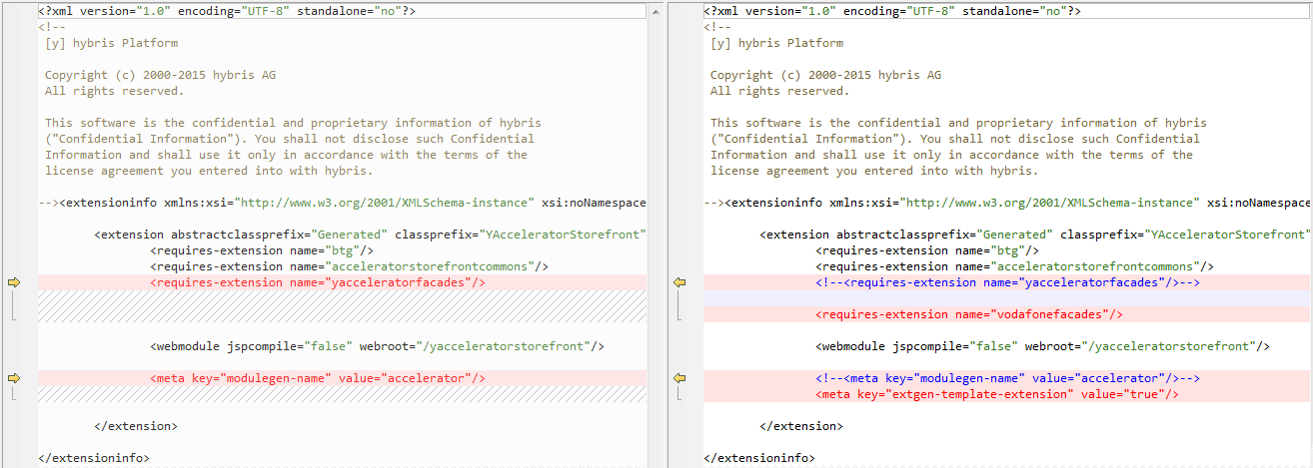

PFB the file.



Existing tag to be commented.

<!--<requires-extension name="yacceleratorfacades"/>-->

New line to replace the existing line.

<requires-extension name="vodafonefacades"/>

Existing tag to be commented.

<!--<meta key="modulegen-name" value="accelerator"/>-->

New line to replace the existing line.

<meta key="extgen-template-extension" value="true"/>

Now Run the below command again.

C:\hybris5700\hybris\bin\platform>ant extgen



After entering the template name, it will ask you to choose the name of your extension.

In this case we will go with the name: vodafoneufestorefront



After this the next step is to choose the package name of your extension.

In this case we will go with the name: hu.vodafone.ufe

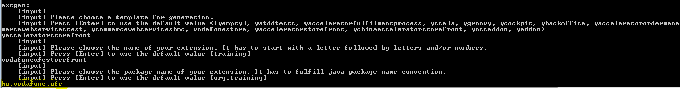

On Completing the process the below message will be shown :

*Next steps:*

*1) Add your extension to your C:\hybris5700\hybris\config/localextensions.xml*

*<extension dir="C:\hybris5700\hybris\bin/custom/vodafoneufestorefront"/>*

*2) Please remove all template extensions (again) before you proceed.*

*3) Make sure the applicationserver is stopped before you build the extension the first time.*

*4) Perform 'ant' in your hybris/platform directory.*

*5) Restart the applicationserver*

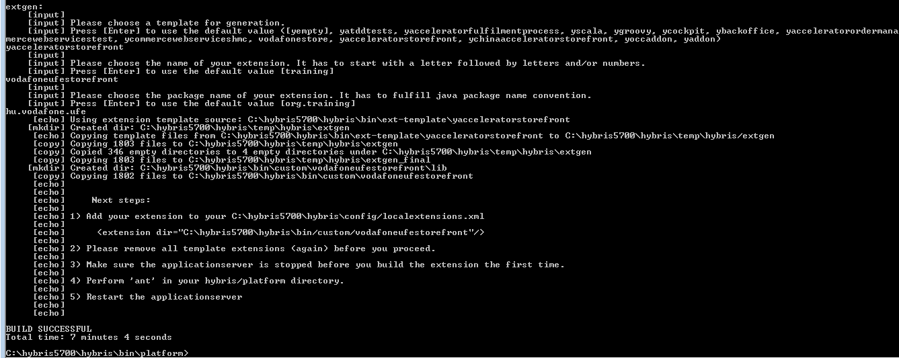

A new “custom” folder will be created in the below path.

C:\hybris5700\hybris\bin

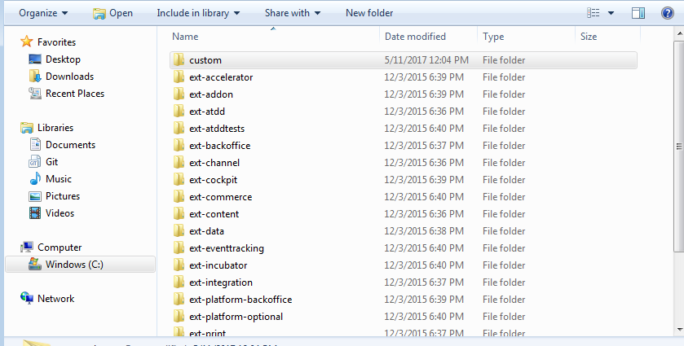

Inside custom folder we will find our new extension “vodafoneufestorefront”

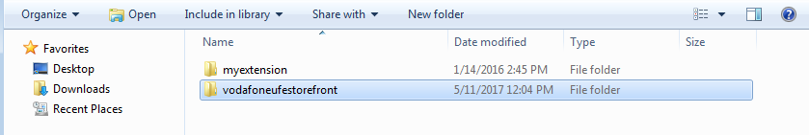

Copy this folder and paste it under ext-vodafone similar to other folder extensions

i.e. the path : C:\hybris5700\hybris\bin\ext-vodafone

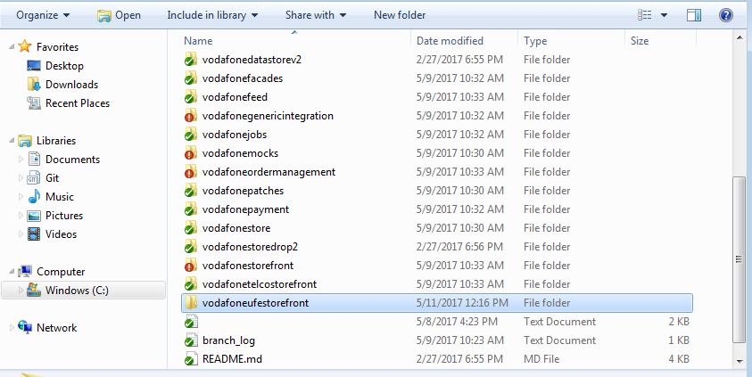

And now give this extension under config.local folder - localextensions.xml.

Got to the path : C:\hybris5700\hybris\bin\ext-vodafone\config.local

Open file : localextensions.xml

Add the below line in the file along with the other extensions.

<extension name='vodafoneufestorefront' />

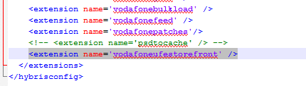

Now delete custom folder from below path

C:\hybris5700\hybris\bin

Now do ant all and start server

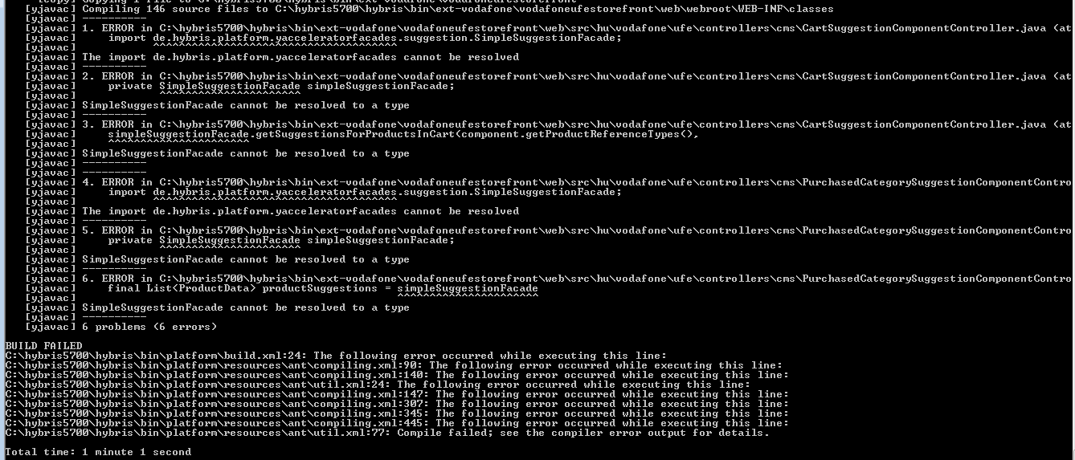

If you encounter error during build. Follow the below steps.

<!--<requires-extension name="yacceleratorfacades"/>-->

<requires-extension name="vodafonefacades"/>

Since we have changes the extension name from yacceleratorfacades to vodafonefacades.

Some files may still refer to it.

But before that got the extension in eclipse. Right click 🡪 Build Path 🡪 Configure Build Path.

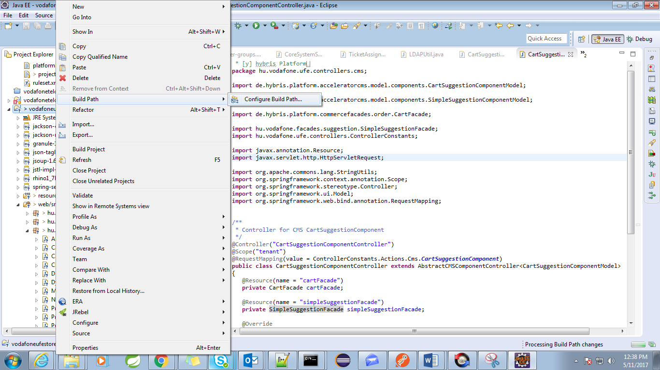

Remove yacceleratorfacades from projects and add vodafonefacades.

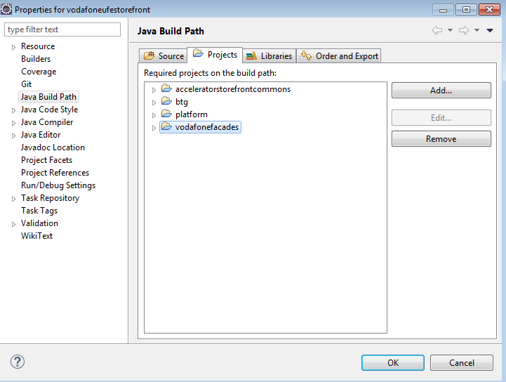

Now replace the yacceleratorfacades imports with vodafonefacades imports.

Ex :

Replace

import de.hybris.platform.yacceleratorfacades.suggestion.SimpleSuggestionFacade;

with

import hu.vodafone.facades.suggestion.SimpleSuggestionFacade;

Search for SimpleSuggestionFacade in vodafonefacades folder and use this package path to replace the import paths.

package hu.vodafone.facades.suggestion;

After the above changes are done do ant all and start server.